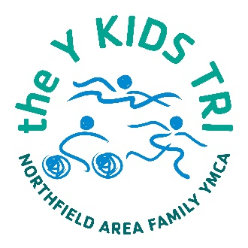
Northfield Y Kids Tri
Saturday, June 22nd
Training Plan
What is a triathlon?
A triathlon is a swim, bike, and run event, completed in that order. Participants will swim, go to the transition area to prepare for the bike, complete the bike course, return to the transition area to drop off their bike, and head to their run. This triathlon is a non-competitive event that’s all about having FUN and feeling GREAT about crossing the finish line!

What are the distances for each age division?
Age Group* | Swim Distance | Bike Distance | Run Distance
Ages 6-7 | 50 meters  (zero depth entry) | 1.25 miles | ¼ mile
Ages 8-10 | 50 meters  (one length in lap lanes) | 2.5 miles | ½ mile
Ages 11-14 | 100 meters  (one lap in lap lanes) | 5 miles | 1 mile
A length is to swim from one end of the pool to the other. A lap is two lengths (down and back the long way).

How do I train?
Training for the Y Kids Tri is helpful but not necessary. A suggested calendar can be found below. Modifications will need to be made based on the age of your athlete.

Training Tips
- Safety First! Always wear a helmet with biking and watch for cars and pedestrians. Make sure your child has running shoes that fit and feel good to exercise in. For younger children, supervision is important as they sometimes are concentrating on speed rather than safety.
- Keep it Fun! Involve the whole family in training activities and look for ways to make it a game.
- Practice the Transition. Your child may be worried about how to move from the swim to bike to run. Set up a mock transition zone in your yard or park so they can become familiar with the set up and timing needed.

 | Sun | Mon | Tues | Wed | Thur | Fri | Sat
Week 1 (May 19-25) | Bike – 20 min (leisurely) | Off | Swim – 50 meters | Bike – 15 minutes | Run – 5 minutes, walk 5 min | Off | Swim – 50 meters
Week 2  (May 26-June 1) | Bike – 20 minutes | Run – 10 minutes | Off | Swim – 5 min. without stopping | Bike – 25 minutes | Run – 15 minutes | Off
Week 3  (June 2-8) | Swim – 100 meters | Bike – 30 min. (Steady Pace) | Run – 20 minutes | Off | Swim – 150 meters | Bike – 30 min (include a hill) | Run – 15 minutes
Week 4  (June 9-15) | Off | Swim – 10 min without stopping | Bike – 25 minutes | Run – 15 minutes | Off | Swim – 200 meters | Bike – 20 min (Steady Pace)
Week 5  (June 16-22) | Try biking for 15 min, then run for 10 min | Off | Swim – 100 meters | Bike – 15 minutes | Run – 10 minutes | Get lots of Rest! | Y KIDS TRI!

